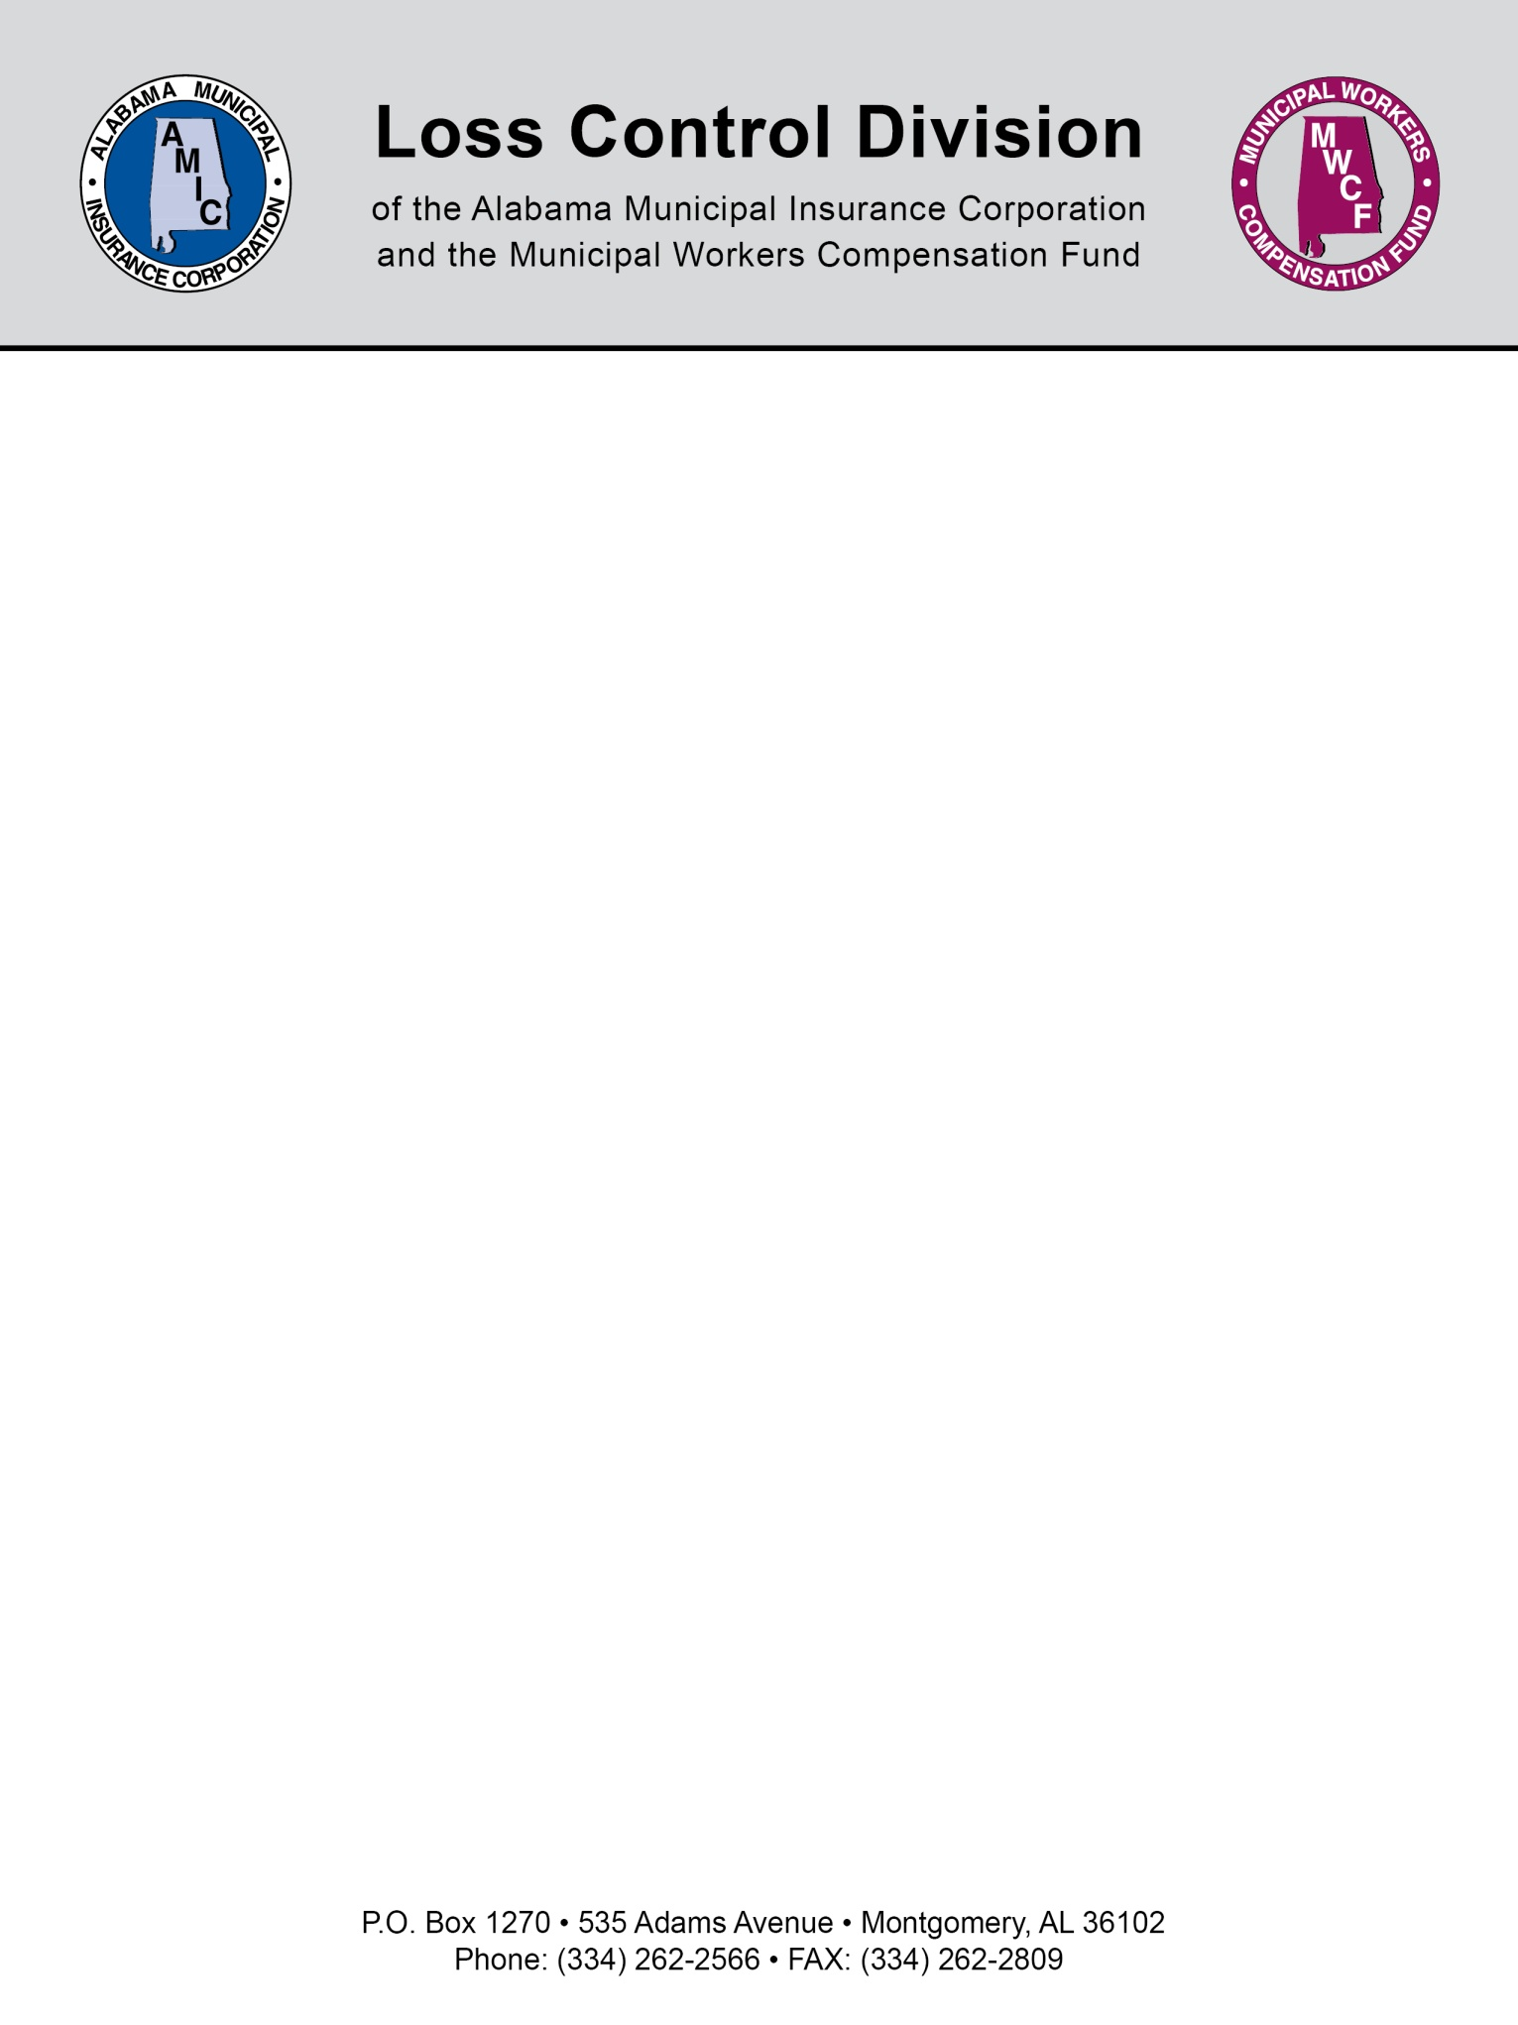

VOLUNTEER WAIVER, RELEASE, HOLD HARMLESS AND INDEMNIFICATION AGREEMENT FOR THE TOWN OF ______________

I have agreed to serve as a volunteer for the Town of __________________, Alabama and I recognize that my volunteer participation is a privilege afforded to me by the Town of _________________, Alabama. I fully understand, appreciate and assume all of the risks associated with my volunteer duties. In exchange for my participation, I hereby agree to the following:

1. I voluntarily waive, release and hold harmless the Town of ___________________, Alabama, its elected and appointed officials, officers, employees, agents and other volunteers from any and all claims, causes of action and damages for bodily injury or death that I may suffer as a result of, or in any manner connected with, directly or indirectly, my participation as a Town of Alabama volunteer when such bodily injury or death is the result of my own negligent or intentional acts or omissions or those of another volunteer. I understand that this waiver and release precludes my right to recovery of damages in the event I am injured in the course of performing my volunteer duties.

2. I shall defend, hold harmless and indemnify the Town of ___________________, Alabama its elected and appointed officials, officers, employees, agents and other volunteers, from and against all damages, claims, liabilities, causes of action, judgments, settlements, costs and expenses (including, but not limited to, reasonable expert witness and attorney fees) that may at any time arise or be claimed by any person as a result of bodily injury, death or property damage, or as a result of any other claim or cause of action of any nature whatsoever, arising from or in any manner connected with, directly or indirectly, my negligent or intentional acts or omissions in performing my volunteer duties for the Town of ___________________ as a volunteer.

I have read, fully understand and agree to the assumption of risk, waiver, release, hold harmless and indemnification terms set forth above.

________________________
Date

________________________________________________________________________Volunteer Signature Printed Name

________________________________________________________________________Volunteer Date of Birth Emergency Telephone Number

________________________________________________________________________
Witness of Volunteer Signature Title

NOTE: If the volunteer is less than 18 years of age, a parent or legal guardian must sign this agreement on behalf of the volunteer.

________________________
Date

________________________________________________________________________
Signature of Parent or Legal Guardian Printed Name

________________________________________________________________________
Witness of Parent Signature or Legal Guardian

Please Sign and Mail or Fax this Form to:

Town of ______________________
Address: ______________________
______________________
Telephone: ____________________

NOTE: This document is not intended to be legal advice. It does not identify all the issues surrounding the particular topic. Public agencies are encouraged to review their procedures with an expert or an attorney who is knowledgeable about the topic. Reliance on this information is at the sole risk of the user.

Rev 8/2013

